E-Sign User Guide for Windows


POS Digicert Sdn. Bhd.

Version 1.0

Document Control
Document History
Version | Date | Author | Change Description
1.0 | 8/9/2017 | Bahrain Suffian | First release

Confidentiality Statement
© POS Digicert Sdn Bhd
This document is the property of POS DIGICERT and no part thereof shall be reproduced, stored in a retrieval system, or transmitted in any form or by any means, electronic, mechanical, photocopying, recording or otherwise without written approval from the management of POS DIGICERT Sdn. Bhd.

Table of Contents

Introduction 2
System Requirement 2
Securemetric Token Middleware Installation 3
E-Sign Installation 6
Running E-Sign 10

Introduction
This manual is intended for ST3 Token installer and E-Sign for Windows.

System Requirement
Before installing SecureToken ST3 Installer, the following requirements must be met:
➢ Supported Operating Systems
Operating System | Windows XP  Windows 2000  Windows Vista  Windows 7  Windows 10
➢ An available USB port on the computer
➢ BIOS supports USB devices, and the USB support feature in CMOS settings is enabled
➢ SecureToken ST3

Below is system requirement for E-Sign for Windows
Requirement | Description
Operating System | Windows XP  Windows 2000  Windows Vista  Windows 7  Windows 10
Prerequisite | SecureToken ST3

E-Sign for Windows is developed to be used with SecureToken ST3 only.




Securemetric Token Middleware Installation
Below are the installation steps for SecureToken ST3.
No | Description / Screenshot
Step 1 | Connect SecureToken ST3 to your computer’s USB port. SecureToken ST3 setup wizard will auto-load. Please note that some computers may not have auto-load enabled, based on the computer setting set by System Administrator.  If auto-load is disabled, proceed to Step 2
 | 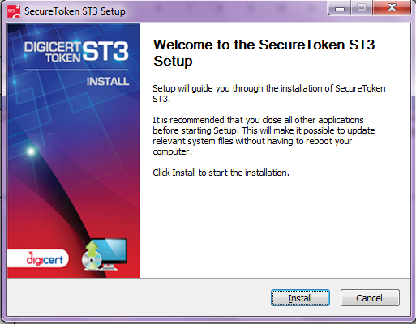
Step 2 | Open Windows Explorer and click on token folder and double click on file setup.exe to run. Screen as per Step 1 will be displayed.
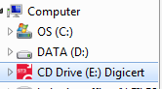

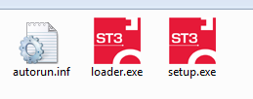

Step 3 | Wait for installation process.
 | 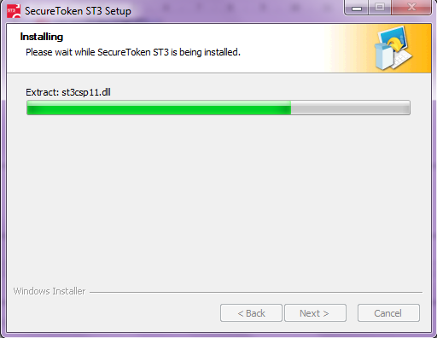
Step 4 | After installation completed, click Finish.
 | 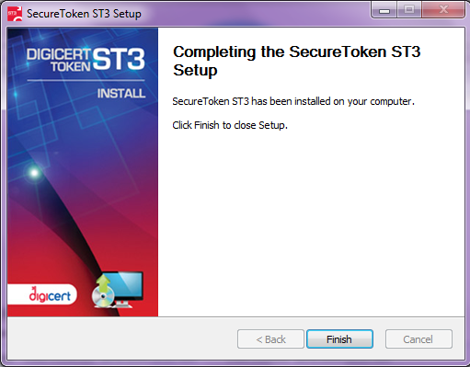
Step 5 | ST3 icon will appear in System Tray.
 | 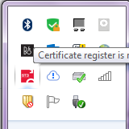
Step 6 | Program group “Digicert” will be created on Start Menu
 | 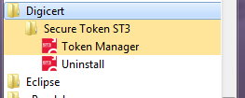
Step 7 | ST3 token middleware will be run automatically upon insertion of ST3 token.  Note : ST3 token installer look and feel may vary between CAs. Please contact respective CA for detail manual.

E-Sign Installation

No | Description / Screenshot
Step 1 | Run Digicert eSign 1.4_Setup.exe by double clicking on filename.
 | 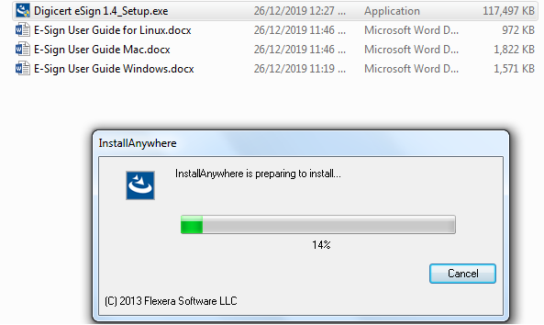
Step 2 | Make sure all browsers is closed before continue. Click Next.
 | 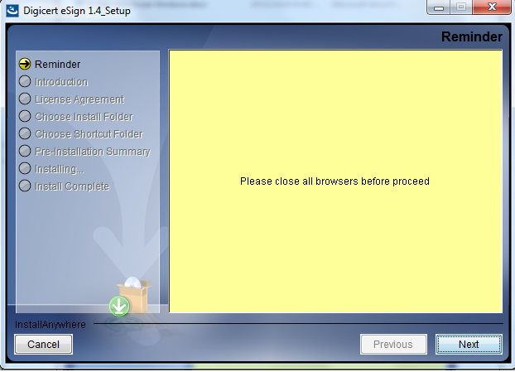
Step 3 | Click Next.
 | 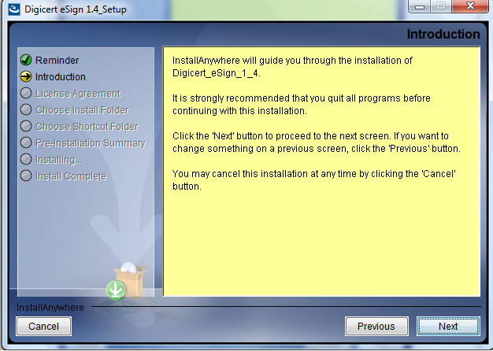
Step 4 | Accept terms and condition and click Next.
 | 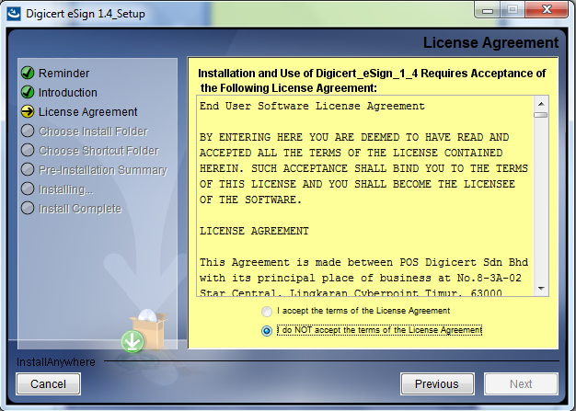
Step 5 | Screen will display installation path of E-Sign. If different folder is required, select button “Choose”. If not, proceed with button Next.
 | 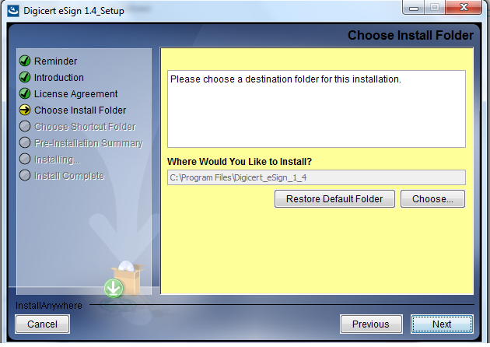
Step 6 | Installer will prompt, the location of product icon. Leave the default setting. Click Next.
 | 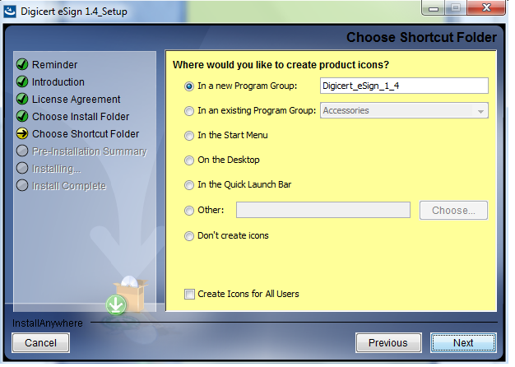
Step 7 | Installer will display installation information detail. Click “Install” to continue.
 | 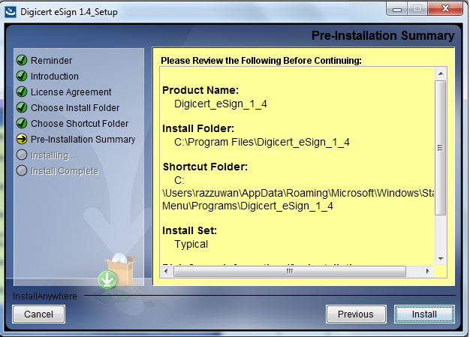
Step 8 | Installer will show installation progress.
 | 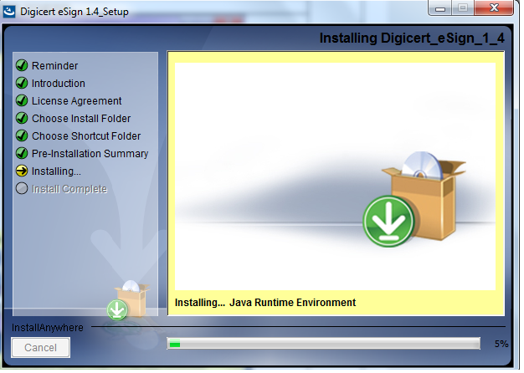
Step 9 | Click on button Done when installation has finished.
 | 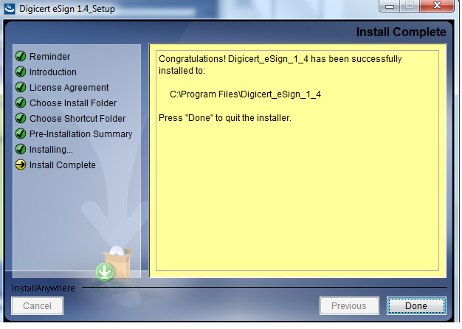
Step 10 | E-Sign for Windows will be available on Start Menu.
 | 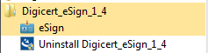

Running E-Sign

No | Description / Screenshot
Step 1 | Before performing any digital signing, make sure E-Sign is installed and running. E-Sign icon will appear as Tray icon.  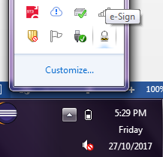
Step 2 | To view ST3 token information, click on E-Sign icon from Tray menu. Click on “Open”.  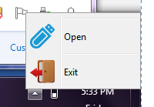
Step 3 | E-Sign user interface will be displayed. Click on menu “Token Information”.  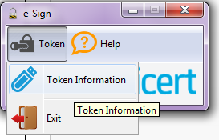
Step 4 | Detail information on ST3 token will be displayed.
 | 